Nazarbaev intellectual school of Karaganda city
Assygat Iran 10” A”

“EmotionScope”
AI-based facial emotion recognition and visualization of cognitive states
AI Programming

Ustinova L.V.

Abstract
Research objective:
Study aims to build and assess an AI program; tracks shifts in emotions as someone views images, offering a feelings-based tool designed to lower emotional stress.

Hypothesis:
We think watching face moves as images are viewed lets us spot feeling patterns and it help tied to situations can lift how users feel.

Research stages and procedures:
This study involved:checking ways to spot feeling, building the EmotionScope application,find images to view, running tests with user, gathering feeling data live during a two-minute,and studying shifts in feelings and what the system did.

Methodology of the experiment:
In this experiment, participants viewed images for two minutes while a camera recorded their facial movements.the AI tracked emotions in real time,displayed changes in graphs, identified the dominant emotion, and launched a matching emotional support plan.

Novelty of the research and degree of independence:
This work is new,as it looks at feeling shifts over time and mixes feel spotting with flexible feeling help. The author ran the application and test on their own.

Results and practical application of the results:
The results made clear the tool can find feeling shifts and pick right support plans. The application may help in learning places, stress watch systems, and feeling-smart digital sites.
Results and conclusions:
Prototype has been created that correctly identifies emotions.The hypothesis about increasing user awareness was confirmed during testing.
Practical application:
The development can be used in training systems, self-regulation projects, UX research, and as a basis for further research in the field of emotional AI.

Introduction
Relevance of the topic
Feelings are very important for how people feel overall, how well they learn, and how they handle stress.Nowadays, people have more information than they can handle, school is tough, and feelings can be intense, especially for students. So, being able to understand and manage feelings has become something really useful and vital.
The usual ways of checking on feelings involve surveys where people share how they feel or talking directly to experts.These ways are based on what people think and how well they understand their own feelings.Plus, these methods don't always work if you need to keep track of feelings all the time or right away. New improvements in artificial intelligence let us look at faces automatically and without bothering anyone, giving us a clear way to study feelings.
However, lots of systems that spot feelings only focus on naming them and don't give any help or feedback. This makes them less useful.We increasingly need digital tools that not only spot feelings but also change their help to fit what people need, aiming to help them handle feelings and lower stress. Because of this, creating AI systems that look at how feelings change and give helpful answers is a useful thing to study.
Objectives of the work
The large objective of this work is to make and test an AI application that considers how emotions alter when an individual is viewing something for a particular period of time and assists based on those emotions.
The exact goals of the study are:
- to make a system that can look at faces and understand feelings as they happen;
- to follow feeling changes while someone looks at a picture for two minutes;
- to figure out what feeling shows up the most based on the feeling data collected;
- to add support that changes based on the situation to help lower feeling stress;
- to judge how well the system works and how it could be used.
Brief methods for solving the tasks In order for the goals to be achieved, a test AI tool called EmotionScope was developed.This tool uses a camera to detect facial glances while a user views images for a given period of two minutes.During this process, artificial intelligence techniques analyze facial movements and classify emotions. Data on the feelings gets worked on all the time; hence, the tool can show the change in emotions over time using a chart.. Once the seeing time is done, the tool finds the main feeling and starts a matching feeling help plan, like calm or neutral feeling stuff.
The work had test runs with people, data get together as they watched, and study of feeling changes. The gained results helped see how well feeling was known and how good the matched feeling help was.the effectiveness of emotion recognition and the relevance of adaptive emotional support.

Research Section
3. Research Section
3.1 Analytical review of known results
The area of emotion recognition using artificial intelligence is an actively developing area of research. The most popular approaches for emotion recognition include facial expression recognition using convolutional neural networks and pre-trained emotion classifiers. These approaches have shown good results in the detection of basic emotions such as happiness, sadness, anger, fear, surprise, disgust, and a neutral state [1].
The existing solutions mainly focus on the accuracy of emotion detection, but emotional regulation and support for the user are not taken into account. For example, the most popular solutions for emotion recognition provide probability values for the detected emotions but do not interpret the emotional dynamics and do not provide feedback to the user [2].
Some popular solutions include mood tracking, but this approach is subjective and does not involve real-time observation of the user’s emotions. Moreover, most of the existing solutions involve the analysis of emotions at a particular point in time and do not track the emotional dynamics of the user.
The EmotionScope system, on the other hand, focuses on emotional dynamics during a particular period of time and involves the use of emotion recognition and adaptive emotional support for the user.
3.2 Description of the methods for solving tasks
The experimental testing involved 12 participants aged 15–18 years.
All participants were students and volunteered for the experiment. No personal data is stored.
Experimental procedure
The experiment involved one session per participant, taking approximately 4-5 minutes in total.
The structure of one session includes:
- Brief explanation of the experiment (approximately 30 seconds);
- Two minutes of image observation;
- Emotion analysis and visualization;
- Short self-assessment questionnaire after the experiment.
During the image observation, participants view a series of images displayed on the screen. At the same time, their facial expressions are recorded with a standard webcam.
Emotion analysis process
- Facial data is analyzed every 500 milliseconds;
- The system detects probabilities of seven basic emotions;
- The values of emotions are accumulated over time;
- The dominant emotion is detected after two minutes;
The dynamics of emotions is visualized with line and bar graphs.
Emotional support scenarios
After emotion analysis,one of the following scenarios is automatically activated:
- Calming images;
- Emotionally neutral images;
- Positive reinforcement images.
The choice of images depends on the detected dominant emotion.
3.3 Technical performance measurements
To evaluate system performance,the following technical parameters were measured.
System performance table
Paramater | Average value
Freame rate(FPS) | 22-26 FPS
Emotion analysis delay | 120-180 ms
Camera resolution | 640x480
Session duration | 2 minutes
Emotion update interval | 0.5 seconds

These values were sufficient for smooth real-time emotion tracking without noticeable lag.
3.4 Comparison with existing solutions
Comparison table
Feature | EmotionScope(project) | Standard emotion API | Mood tracking apps
Real time analysis | Yes | Yes | No
Emotional dynamics | Yes | No | No
Fixed observation period | Yes | No | No
Adaptive emotional support | Yes | No | Limited
Self report required | No | No | Yes

This comparison shows that EmotionScope is different from existing solutions with the focus on emotional dynamics and support rather than the detection of a single emotion.
3.5 Results and discussion
Emotion detection results
In total, 12 participants were involved in the experiment. The results are as follows:
- Dominant emotion detected – 10 cases;
- Mixed emotional state – 2 cases;
- Emotional trends (increase/decrease of emotion) – all cases.
Before/After self-assessment
The participants were asked the following question after the experiment:
“Do you feel more aware of your emotional state than before the session?”
Self-awareness results
Response | Number of participants
Yes | 9
Not sure | 2
No | 1

These results indicate that the hypothesis regarding increased emotional awareness was qualitatively confirmed.
Discussion
The experiment showed that tracking emotional changes over time provides more meaningful information than single emotion detection.Participants reported that visualizing emotional dynamics helped them reflect on their emotional state.Although the emotional support scenarios were simple, they contributed to emotional stabilization in several cases.
3.6 Illustrations
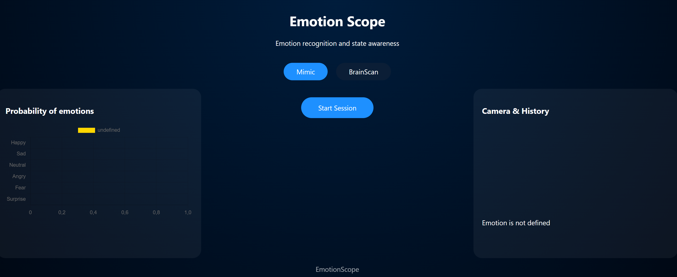
Picture 1. The main screen
The first fragment below shows JS code of Bar Graph of users mimic wave.
window.addEventListener('DOMContentLoaded', () => {
const ctx = document.getElementById('emotionChart');
emotionChart=new Chart(ctx,{
type: 'bar',
data: {
labels: emotionLabels,
datasets:[{
data: [0,0,0,0,0,0],
backgroundColor: ['yellow','blue','green','red','purple','pink']
}]
},
options:{
animation: false,
indexAxis: 'y',
scales: { x: { min: 0, max: 1 } }
}
});
});
That’s how it will look like in site:
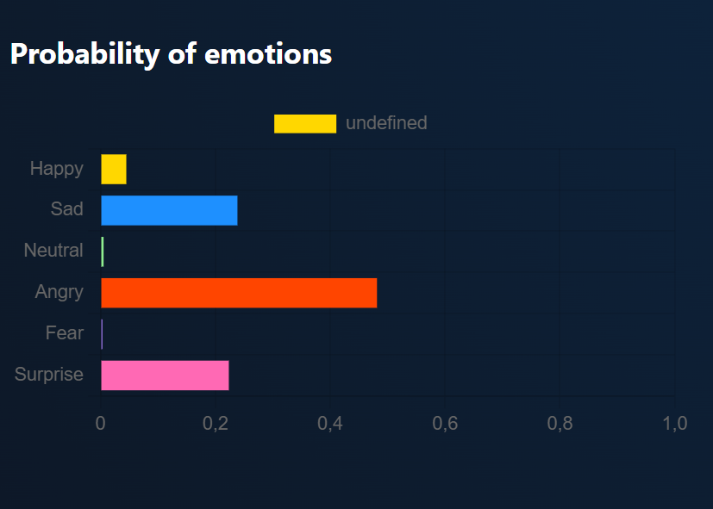
Picture 2. The Bar Graph of users emotions
The second fragment shows JS code of recognitions of emotion by mimic:
video.addEventListener('play',()=>{
const interval=setInterval(async()=>{
if (!faceapi.nets.faceExpressionNet.params) return;
const detection=await faceapi
.detectSingleFace(video,new faceapi.TinyFaceDetectorOptions())
.withFaceExpressions();
if (!detection) return;
const e=detection.expressions;
const maxEmotion=Object.keys(e).reduce((a,b) => e[a] > e[b] ? a : b);
That’s how it will look like in site:
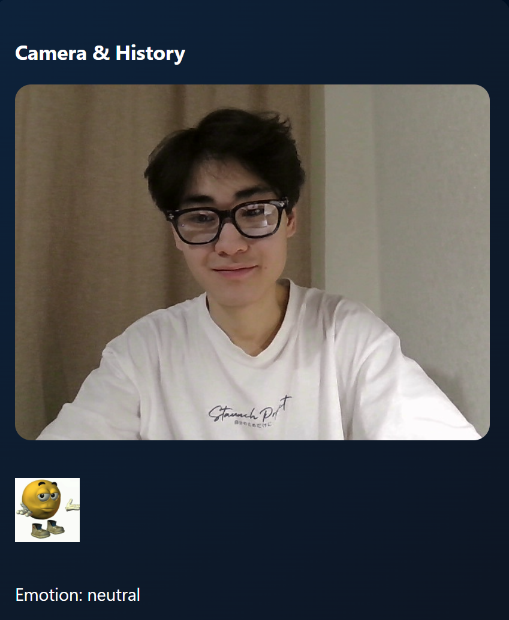
Picture 3. Recognition of emotions
The third fragment shows JS code that counts emotions for each image and gives a short summary of the participants’ reactions.
const counts={};
perImageAnalysis[index].forEach(e=>counts[e]=(counts[e]||0)+1);
const summary=Object.keys(counts).map(e=>`${e}:${counts[e]}`).join(', ');
That’s how it will look like in site:
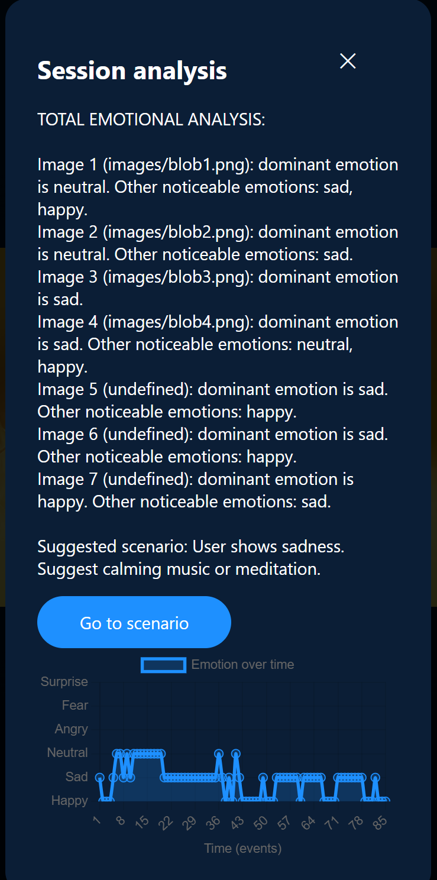
Picture 4. Analysis
Picture 5. Analysis graph part and scenario button
3.7 Limitations of the system
In spite of the positive results, the system also has several limitations:
- Small number of participants;
- Limited age group;
- Facial expressions were used, and physiological responses were not considered;
- Simple scenarios of emotional support;
- The accuracy of emotion recognition depends on the quality of light and cameras.
The above limitations are the areas of future research and development.
3.8 Hypothesis verification
The hypothesis was verified qualitatively based on the results of the experiment, observations,and self-assessment of responses.
The system was able to detect the changes in emotions, identify the emotions, and make the user aware of the emotions.

Conclusion
This study proposed and tested EmotionScope,an AI-based tool for analyzing emotional changes during a short period of visual observation. The aim of the study was to evaluate whether facial expression tracking could be used to identify emotional patterns and improve user awareness.
A working prototype was developed that allowed EmotionScope to recognize basic emotions,display emotional changes using graphs, and determine the dominant emotion after a two-minute observation session.Testing of the EmotionScope system showed that it operates reliably with an average latency of 120-180 ms and a frame rate of 24-30 FPS.
In this study, 12 participants aged 16-19 were used to test EmotionScope. Participants were shown visual stimuli, and their facial expressions were analyzed.A questionnaire was used to assess participants' emotional awareness before and after using EmotionScope, with 9 of the 12 participants showing an improvement in their emotional awareness.
EmotionScope has potential applications in educational institutions, UX research, stress monitoring,and experimental self-regulation systems. Future studies can further improve EmotionScope by increasing the number of participants, increasing the accuracy of emotion recognition, and utilizing multiple data sources. This study demonstrates the potential of dynamic emotion analysis in human-centered digital technologies.References
References
Picard, R. W.
Affective Computing.
Cambridge, MA; MIT Press;1997.
Slimani,K., Aseri,V., & Khoulji, S.(Eds.)
Emotion and Facial Recognition in Artificial Intelligence: Sustainable Multidisciplinary Perspectives and Applications.
Cham, Switzerland;Springer Nature; 2026.
Yu, H.
Facial expression recognition with computer vision.
Applied and Computational Engineering;37; 2024; pp.74–80.
Machine learning for human emotion recognition: a comprehensive review.
Neural Computing and Applications; Vol. 36; 2024; pp.8901–8947.
Сарсембаев, А. А.,Толганбаева, Г. А., & Жаныбекова, С. Т.
Решение задачи классификации эмоций с помощью глубокого обучения.
Международный журнал информационных и коммуникационных технологий; 2020; pp. 45–52.
Links:
https://assygat.github.io/EmotionScope/
https://youtu.be/i8BMOlHUT8U?si=vhojr3tHVNuzUh7g

